Montreal, July 22, 2019

Dear ,

We are delighted to offer you legal coverage for your future real estate transaction in the form of a Sutton Secur certificate.

Your Sutton Secur certificate is offered compliments of your Sutton – Québec affiliated real estate broker, , and covers you for up to $3,000 in legal fees in the case of a legal issue or dispute arising related to the purchase of your property, valid for life, or as long as you continue to own the property covered by the certificate.

Enjoy peace of mind knowing you're covered, and expect outstanding legal help should you need to request assistance!

In the email you received, please find your official Sutton Secur certificate. To help you learn about this innovative program you now benefit from, we've also included the complete terms of service of the Sutton Secur program and frequently asked questions and answers.

REQUEST LEGAL ASSISTANCE

In the event you need to make a request for legal assistance, simply fill out our online form at SuttonSecur.com/Assistance and you will be contacted within 24 hours.

For any question concerning the program, please contact us at 514.558.8774, toll free at 1-844-558-8774, or by email at info@suttonsecur.com
We are delighted to count you among our clients and we hope we can accompany you in each of your future transactions.

Sincerely,

The Sutton Secur Team
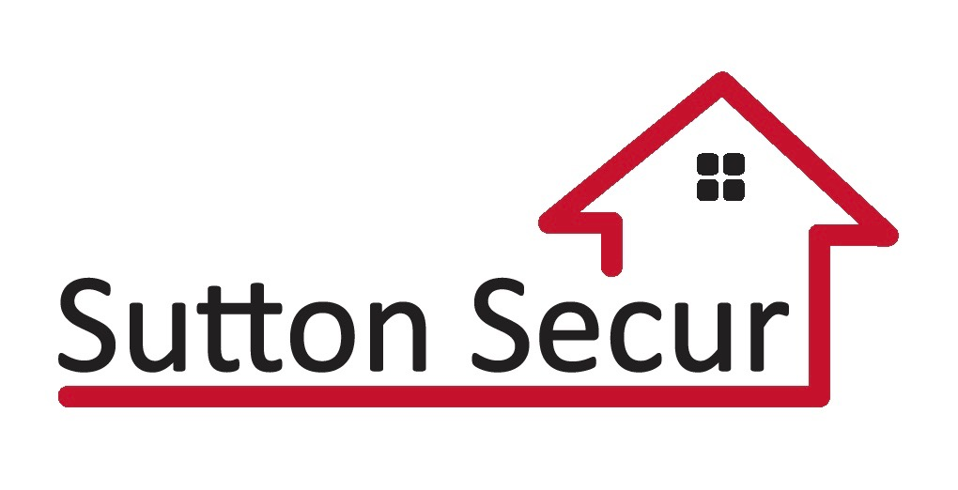
514.558.8774
info@suttonsecur.com

